**ECE3003 – Microcontroller And Its Applications**

**TASK - IV**

**Name : Guneet Arora**

**Registration Number: 16BEC0578**

**Slot : L37 + L38**

**Submitted to : Prof. Chitra P**

**Program 1**

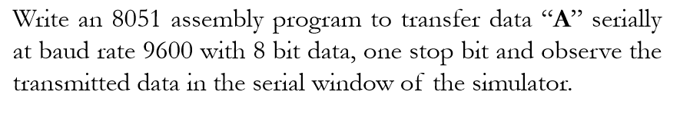

**Code**

ORG 0000H

XX: MOV DPTR,#MYDATA

MOV TMOD,#20H

MOV TH1,#-3

MOV SCON,#50H

SETB TR1

MOV R1,#14

AGAIN: CLR A

MOVC A,@A+DPTR

MOV SBUF,A

HERE: JNB TI,HERE

CLR TI

INC DPTR

DJNZ R1,AGAIN

SJMP XX

MYDATA: DB 'VIT UNIVERSITY'

END

**Output**

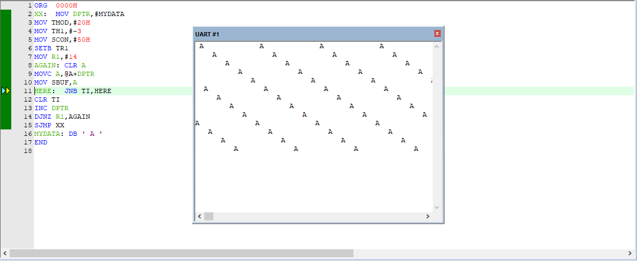

**Program 2**

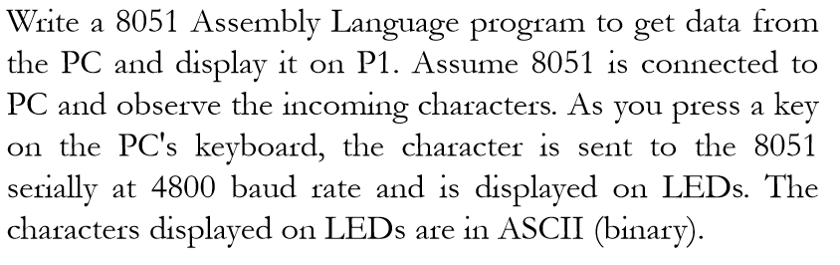

**Code**

ORG 0000H

MOV TMOD,#20H

MOV TH1,#-6

MOV SCON,#50H

SETB TR1

HERE:JNB RI,HERE

MOV A,SBUF

MOV P1,A

CLR RI

SJMP HERE

END

**Output**

**‘C’ from UART to P1.**

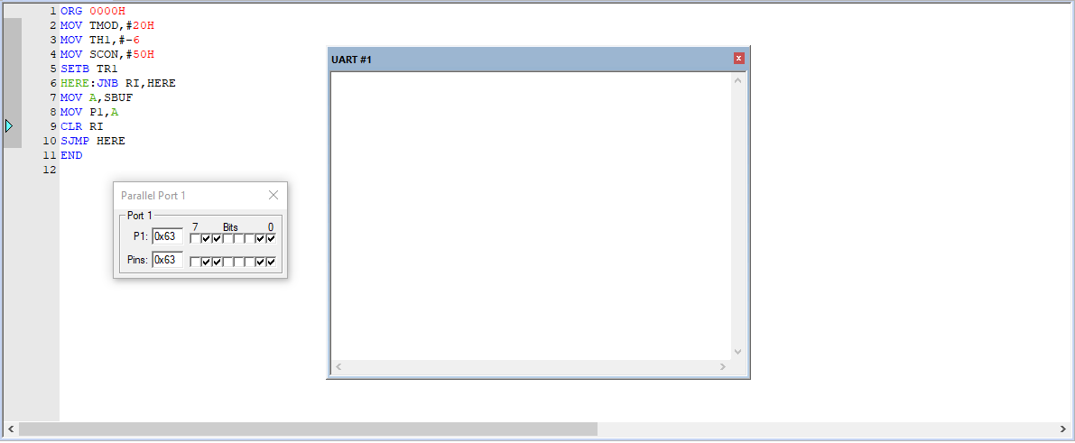

**‘A’ from UART to P1.**

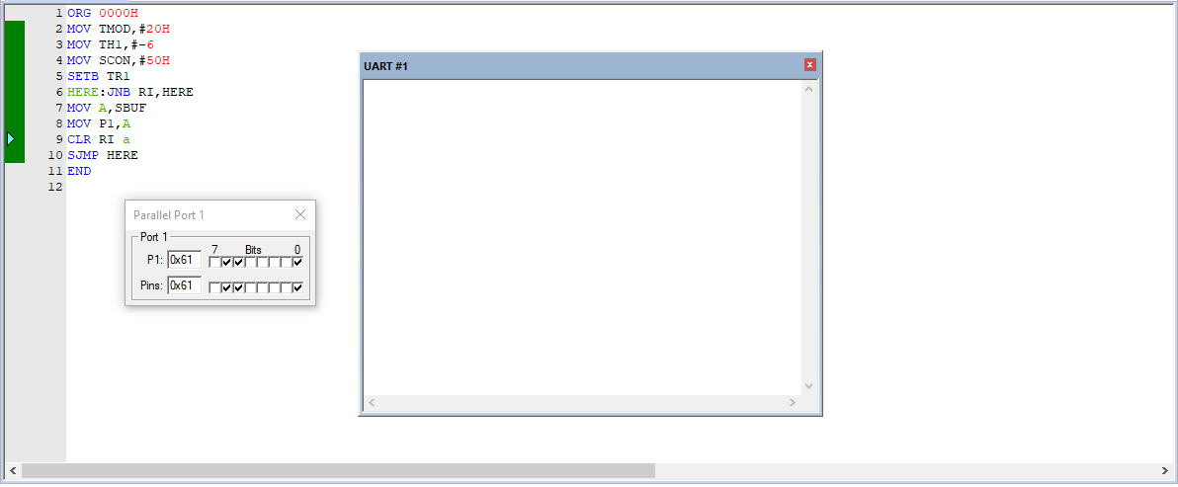

**Task 4A**

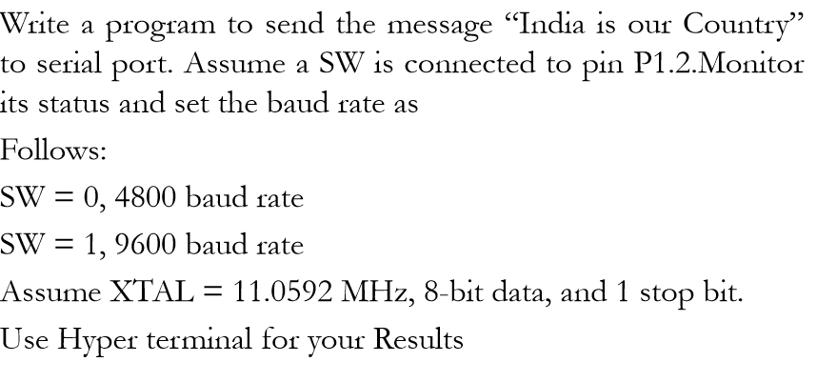

ORG 300H

DB "India is our country."

ORG 000H

MOV R0, #20H

SETB P1.2

MOV TMOD, #20H

MOV SCON, #50H

MOV C, P1.2

JC L1

MOV TH1, #-6

SJMP L2

L1 : MOV TH1, #-3

L2: MOV DPTR, #300H

SETB TR1

BACK : CLR A

MOVC A, @A+DPTR

MOV SBUF, A

HERE: JNB TI,HERE

CLR TI

INC DPTR

DJNZ R0, BACK

END

**Output**

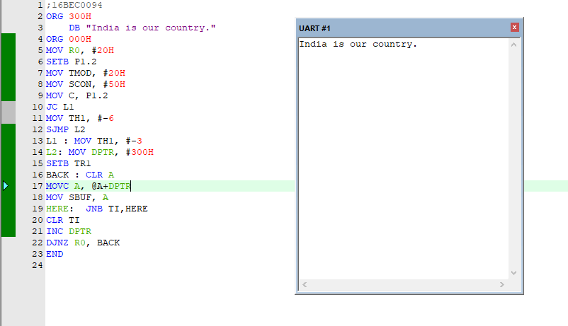

**Task 4B**

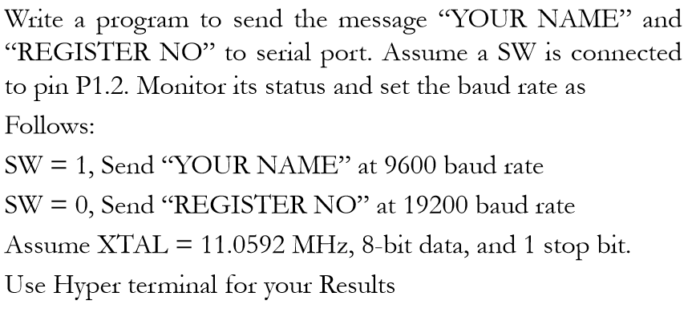

**Code**

ORG 300H

DB "GUNEET ARORA"

ORG 200H

DB "16BEC0578"

ORG 000H

MOV C, P1.2

JC L1

MOV A, PCON

SETB ACC.7

MOV PCON, A

MOV TH1, #-6

MOV DPTR, #200H

SETB TR1

BACK: CLR A

MOVC A, @A+DPTR

MOV SBUF, A

HERE: JNB TI, HERE

CLR TI

INC DPTR

DJNZ R1, BACK

L1: MOV TH1, #-3

MOV DPTR, #300H

SETB TR1

BACK2: CLR A

MOVC A, @A+DPTR

MOV SBUF, A

HERE2: JNB TI, HERE2

CLR TI

INC DPTR

DJNZ RO, BACK2

SJMP START

END

**Output**

**Name : Guneet Arora**

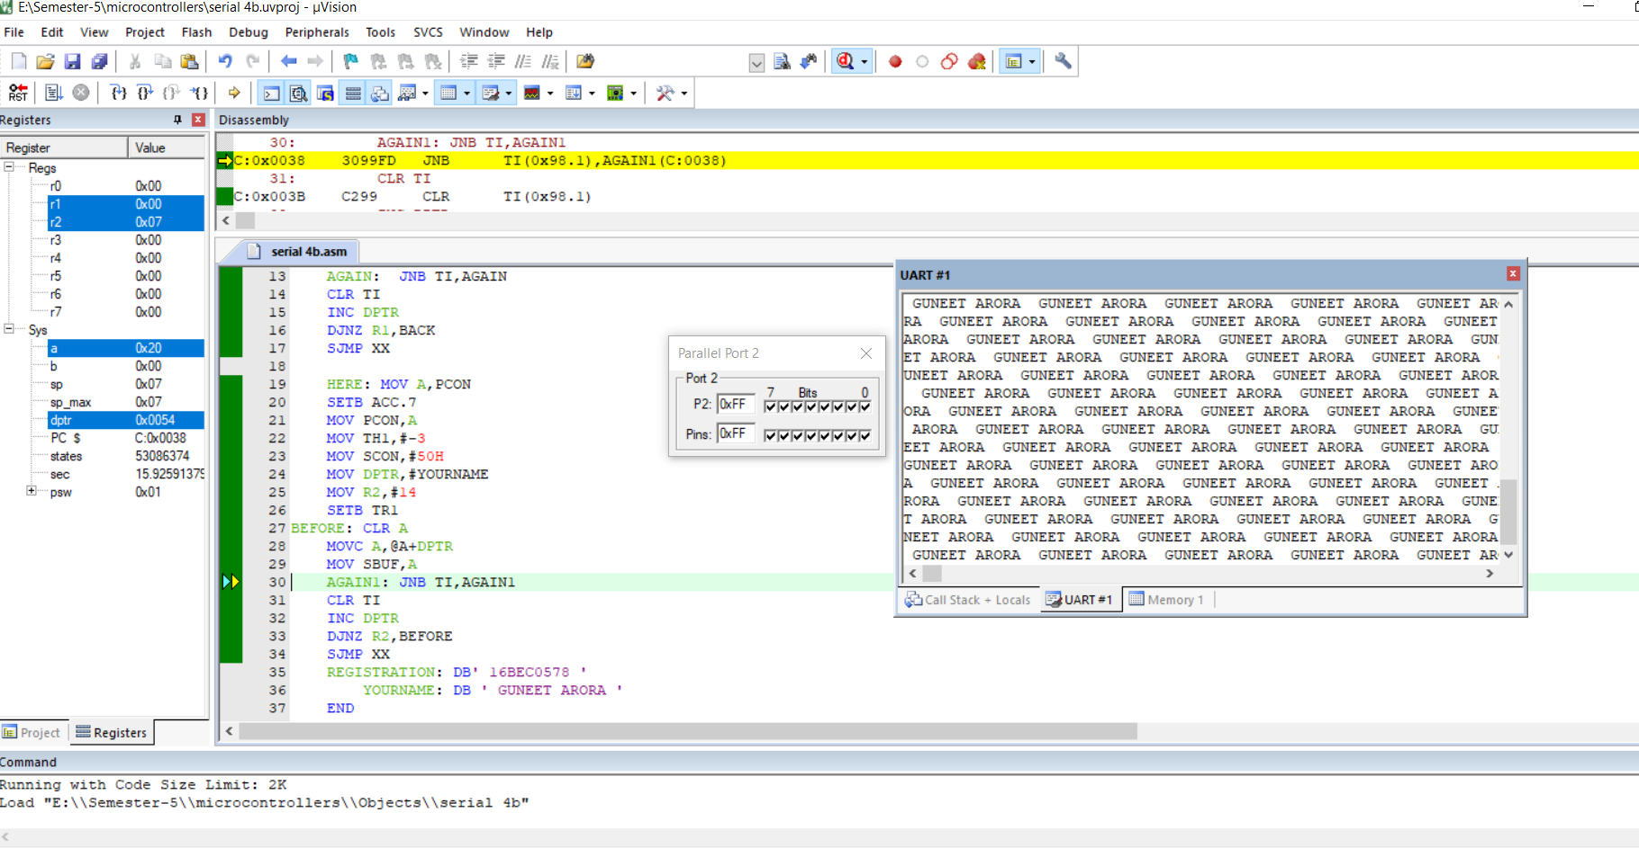

**Registration Number : 16BEC0578**

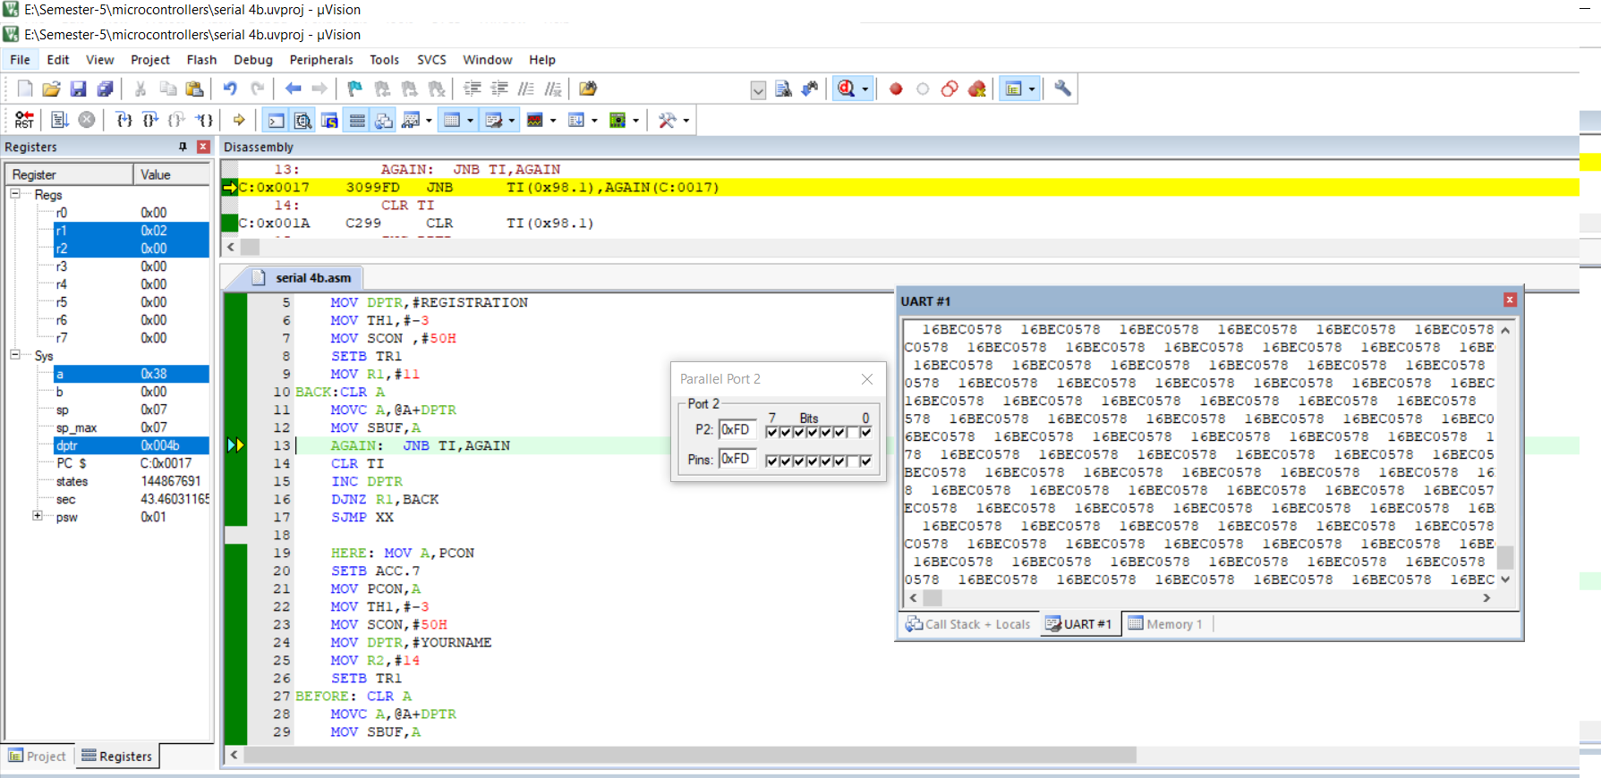

**Program 1**

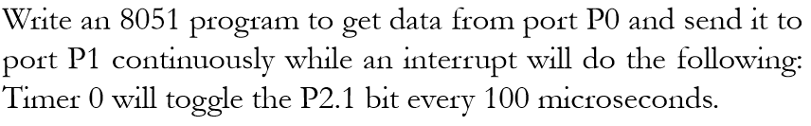

**Code**

ORG 000H

LJMP MAIN

ORG 50H

MAIN: MOV P0,#0FFH

MOV P1,#00H

MOV IE,#82H

MOV TMOD,#02H

MOV TH0,#02H

SETB TR0

BACK:MOV A,P0

MOV P1,A

SJMP BACK

ORG 0BH

CPL P2.1

RETI

END

**Output**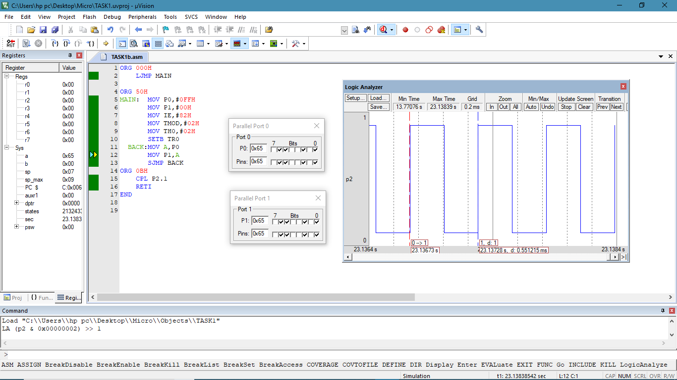

**Program 2**

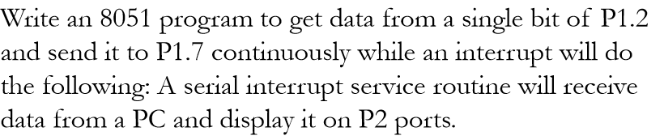

**Code**

ORG 000H

LJMP MAIN

ORG 50H

MAIN:

MOV P2,#00H

MOV P1,#00H

SETB P1.2

CLR P1.7

MOV TMOD,#20H

MOV TH1,#-3

MOV SCON,#50H

MOV IE,#90H

SETB TR1

BACK:MOV C,P1.2

MOV P1.7,C

SJMP BACK

ORG 23H

JNB TI,L1

CLR TI

L1:JNB RI,L2

MOV A,SBUF

MOV P2,A

CLR RI

L2:RETI

END

**Output**

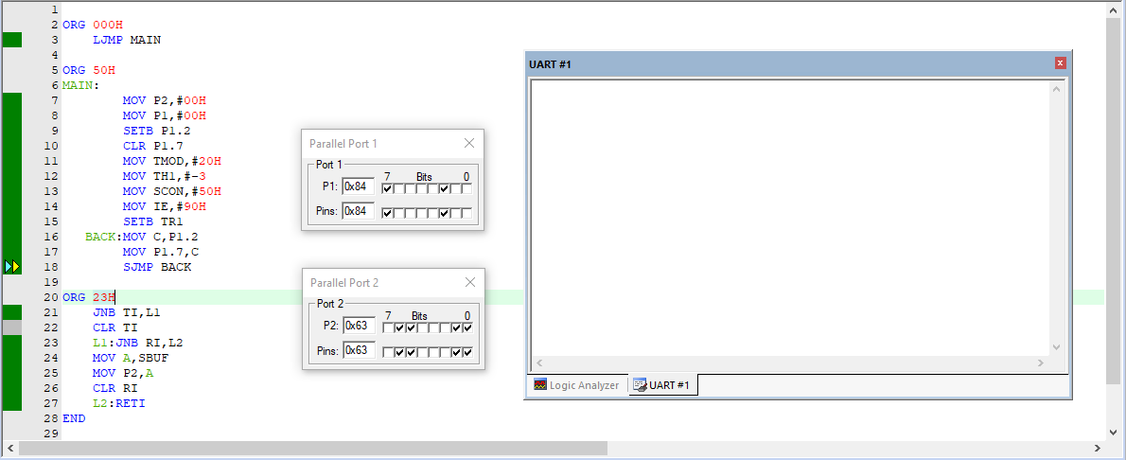

**Task 4C**

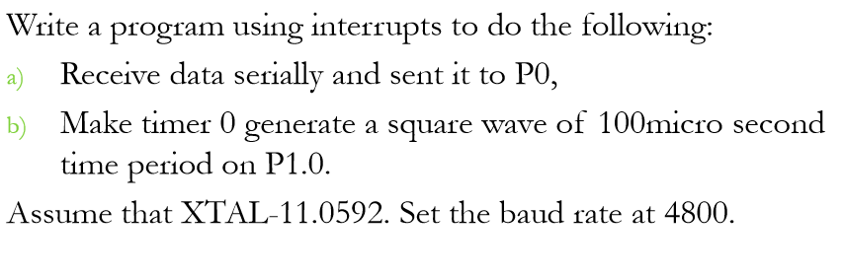

**Code**

ORG 00H

LJMP MAIN

ORG 023H

JNB RI,L2

MOV A,SBUF

MOV P0,A

CLR RI

L2:RETI

ORG 00BH

CPL P1.0

RETI

ORG 050H

MAIN:MOV P0,#0FFH

MOV IE,#92H

MOV SCON,#50H

MOV TMOD,#22H

MOV TH1,#-6

MOV SCON,#50H

SETB TR1

MOV TH0,#0A3H

SETB TR0

SJMP $

END

**Output**

Letter ‘A’

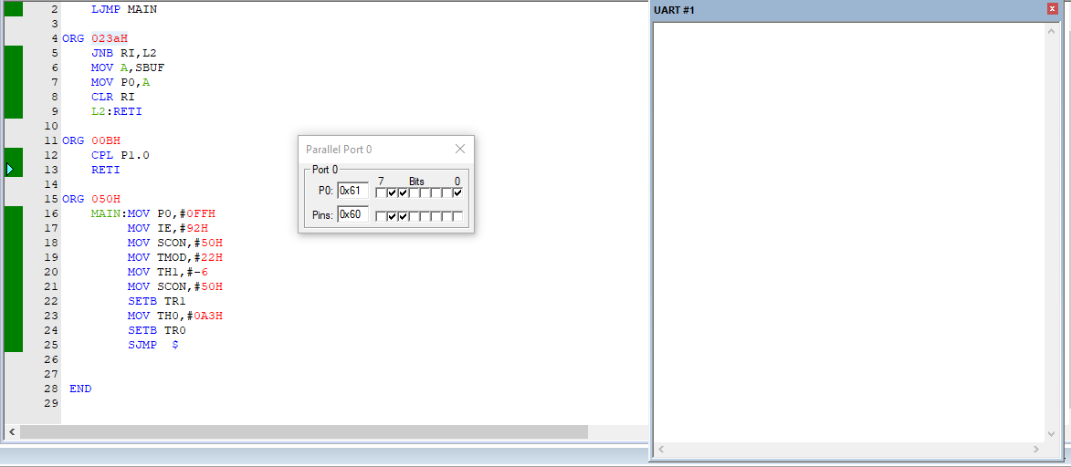

Letter ‘B’

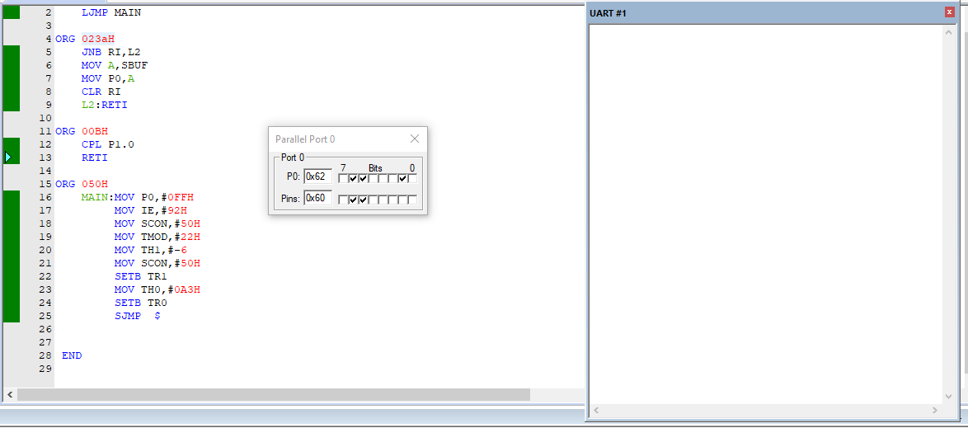

Analyzer Window Output

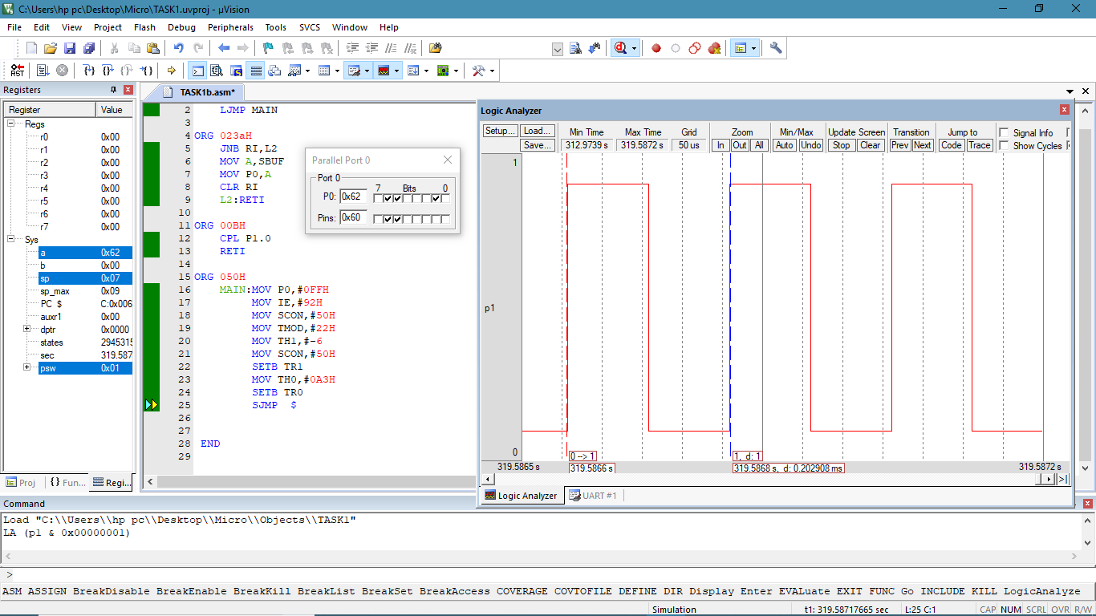

**Task 4D**

Write a 8051 assembly program using timer 0 to generate a 500 Hz and timer 1 to 7kHz square wave frequency on P1.0 and P1.1 respectively using Interrupts. Then examine the frequency using the KEIL IDE inbuilt Logic Analyzer.

Screenshot:

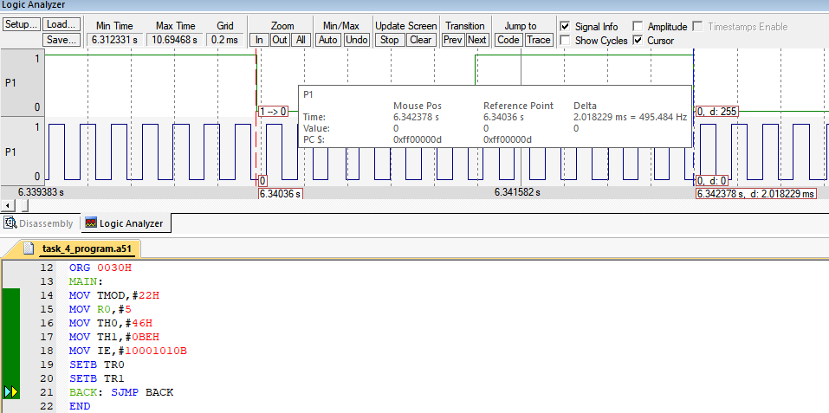

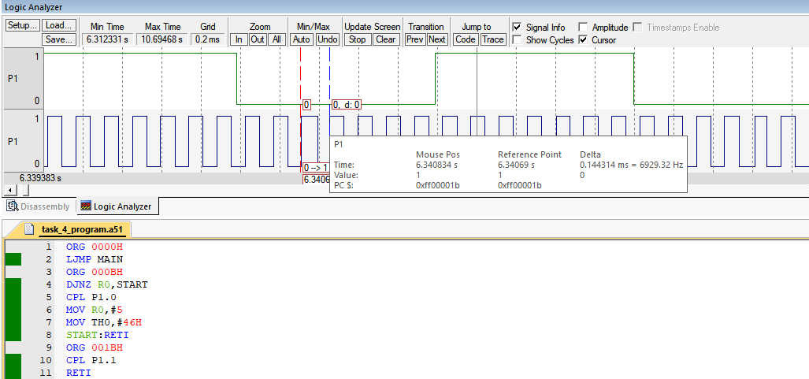

Code:

ORG 0000H

LJMP MAIN

ORG 000BH

DJNZ R0,START

CPL P1.0

MOV R0,#5

MOV TH0,#46H

START:RETI

ORG 001BH

CPL P1.1

RETI

ORG 0030H

MAIN:

MOV TMOD,#22H

MOV R0,#5

MOV TH0,#46H

MOV TH1,#0BEH

MOV IE,#10001010B

SETB TR0

SETB TR1

BACK: SJMP BACK

END